**Steps to Transform and Documentation**

1. **Steps to Transform**
2. Install Python 2.7.16. Also install libraries pandas and pyodbc.

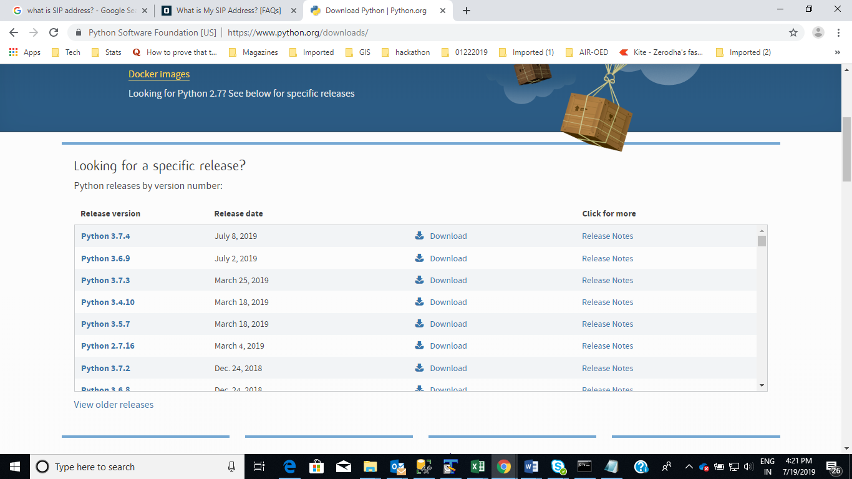

1. Make sure you have attached both AIR Exposure CEDE and AIRReference_CEDE databases to your DB server:

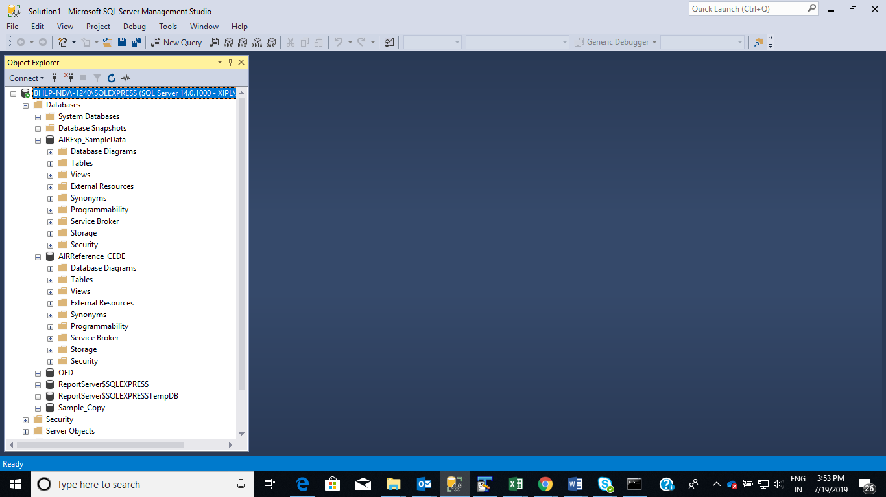

1. Download github repository from master branch at <https://github.com/shivamspj/AIR-CEDE-to-OED-file> as shown in screenshot below

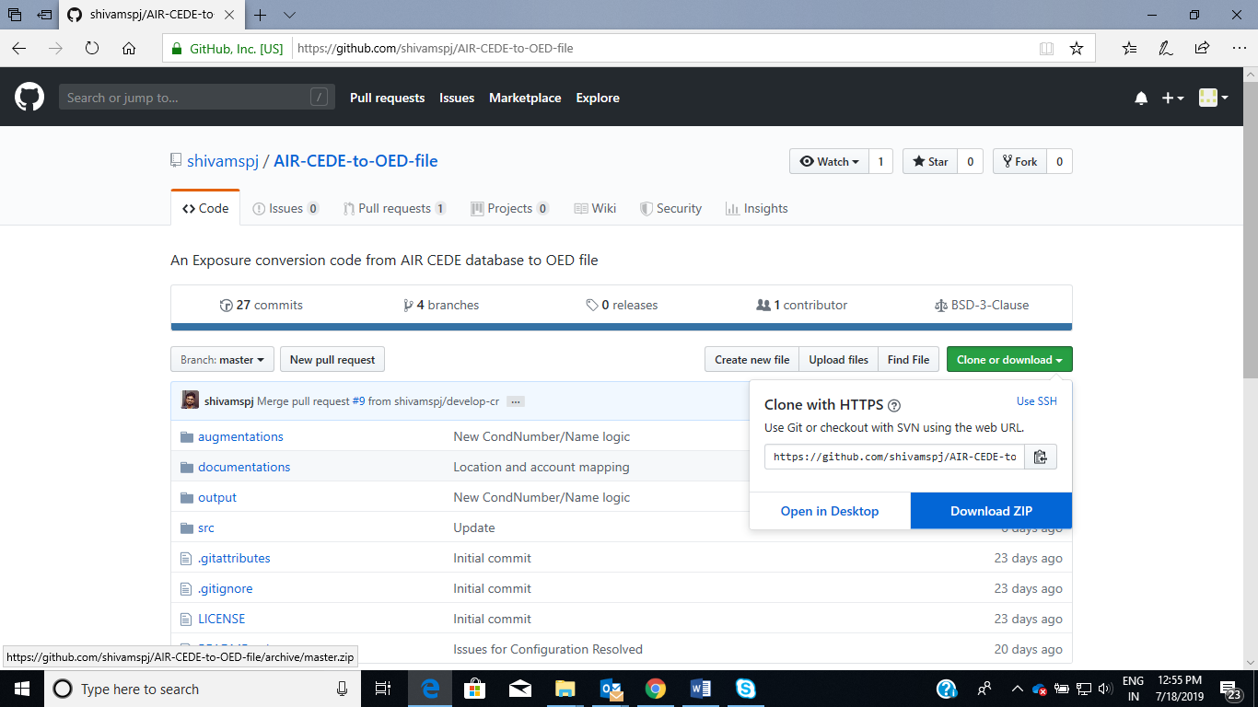

1. From the downloaded master branch folder open Config file at “…\AIR-CEDE-to-OED-file-master\augmentations\config.ini", make sure to provide server name/database names at line no. 15/16 and 23/24 as shown below. Save and close the file.

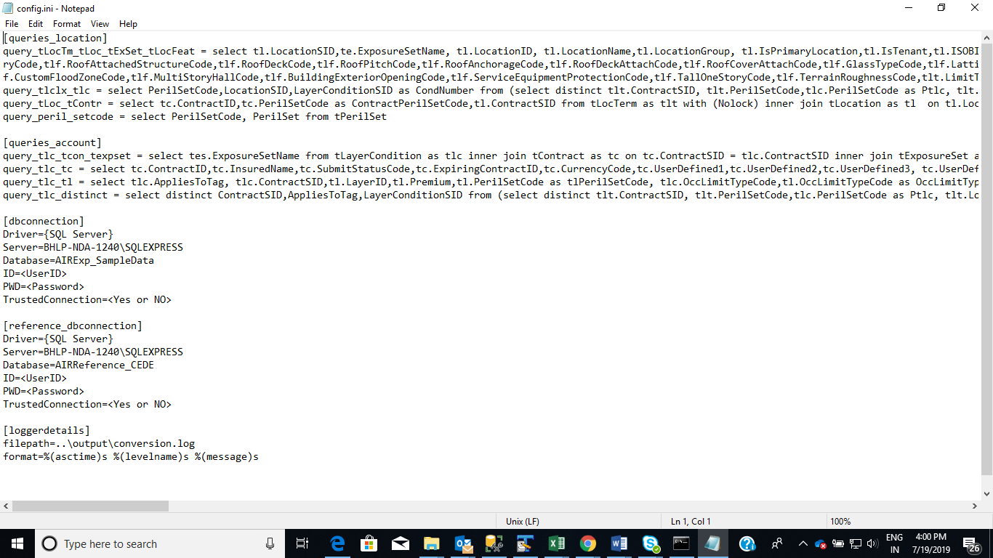

1. Delete (optional) existing two OED output files (OED_account_inout.csv and OED_location_input.csv) from output folder “…\AIR-CEDE-to-OED-file-master\output”. Otherwise the files will be overwritten.

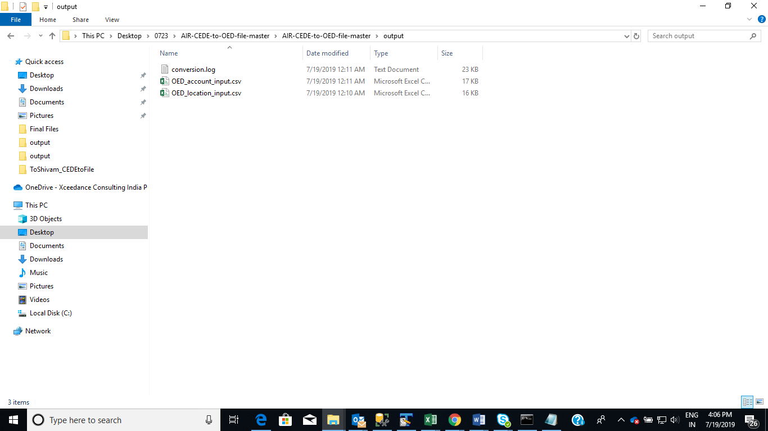

1. Open command prompt (CMD screenshot below).

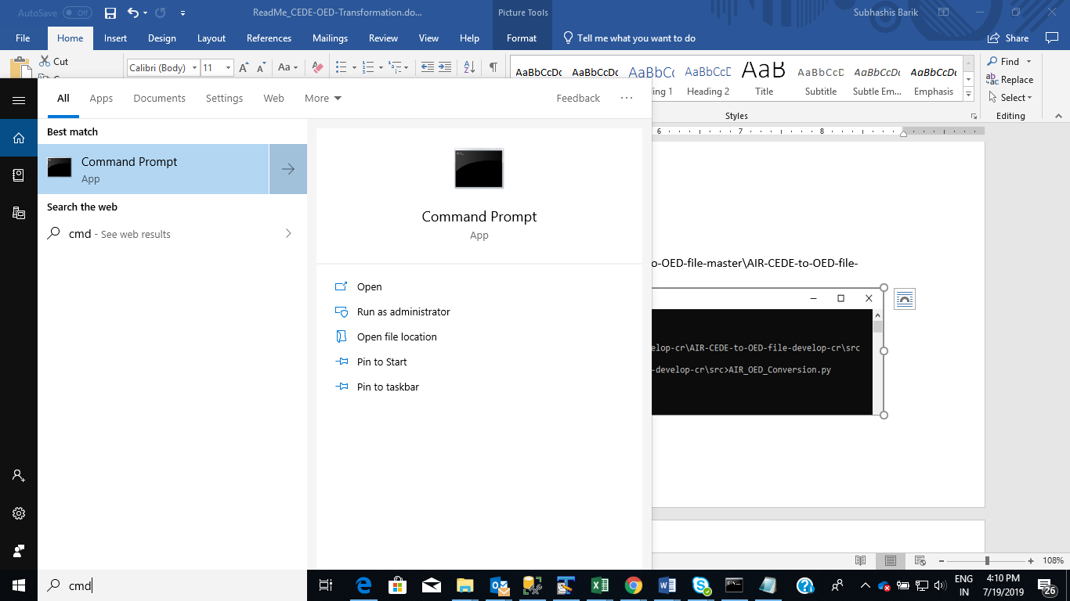

1. Change to source code path “…\AIR-CEDE-to-OED-file-master\src”. Next, type AIR_OED_conversion.py. Press ‘Enter’ to run program

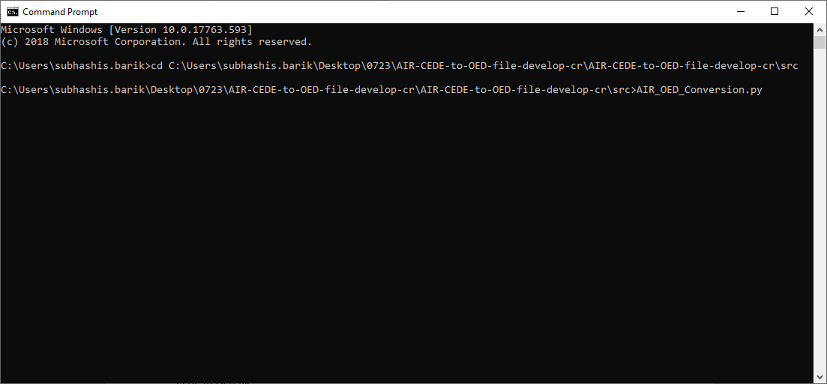

1. Done (progress and completion message will show as in the screenshot). It takes couple of minutes to generate Location/Account File while logging progress. Wait to see "Successfully written converted file in output folder" message in the command prompt.

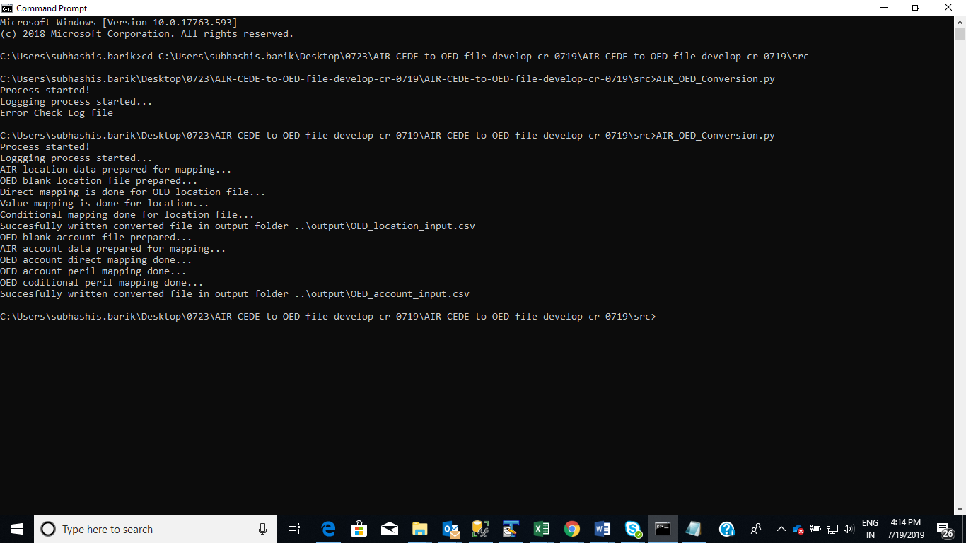

1. The converted file would be written out in the output folder “…\AIR-CEDE-to-OED-file-master\output”- refer the screenshot of output below. If there is any error in conversion, please refer to the conversion log for error details and act accordingly:



1. **Documentation**

Following documentation has been prepared to provide wholistic information on CEDE to OED Files transformation tool:

* 1. **Mapping files in Documentation Folder**

1. AIR_OED_FieldMapping_CEDEtoFile_Account_Final.xlsx

This file contains direct field to field mapping between CEDE and OED Account file reporting fields to populate information about the account including inception, expiration dates. This does not contain peril mapping and financial terms mapping

1. AIR_OED_FieldMapping_CEDEtoFile_Location_Final.xlsx

This file contains mapping of all information about covered location including Address, Risk Values, Primary and Secondary Risk Attributes. Most fields are direct mappings from CEDE. Fields like perils, cons, occ, geomatchlevel, units refer to additional value mapping tables before assigning appropriate values into respective columns. Condition Number assignment follows a separate logical flow.

1. AIR_OED_ValueMap_CEDEtoFile_Final.xlsx

This file contains value mapping from CEDE to OED to transform construction codes, occupancy codes, unit codes and geomatchlevel codes.

1. CEDE_OEDFile_PerilCodeMapping_Final.xlsx

This file is used to convert numeric peril set codes in CEDE database to Textual peril codes in OED Location and Account files. The table provides smallest level peril code mapping between tPeril codes and OED codes and the instruction to convert a CEDE perilset code into a combination of OED peril set codes. Repeat Peril codes are not allowed in OED. A subset and superset of peril codes are not allowed in OED.

1. Location_DedLimit_Instruction_Final.docx

This file contains logical mapping of all supported Location level insurance terms from CEDE to OED files including assignment of Condition Number in OED location file.

1. AccountFile_Terms_Instructions_Final.docx

This file contains logical mapping of all supported Layer and Sublimit level insurance terms from CEDE to OED files including assignment of Condition Number, Condition Name in OED location file.

* 1. **Tested results in Testing Folder**

1. CEDEtoFile_Manual_AccountFile_ForTestingReference.xlsx

This Account file was manually created for testing output Account file from transformation tool. For each field in the account file, the value from tLayerCondition, tLayer, tContract, tExposureset were extracted by look up. Tlayercondition table was used as the base file to write out each field value in OED file corresponding to each record in tLayerCondition.

1. CEDEtoFile_Manual_LocationFile_ForTestingReference.xlsx

This Location file was manually created for testing output Location file from transformation tool. For each field in the account file, the value from tLocation, tLocterm, tContract, tExposureset were extracted by look up. Tlocterm table was used as the base file to write out each field value in OED file corresponding to each record in tLocterm.

1. OED_account_input_comparision.xlsx

This file demonstrates that the tool output account file exactly matched the manually created account file

1. OED_location_input_comparision.xlsx

This file demonstrates that the tool output location file exactly matched the manually created location file

1. OED_account_input_UniqueRecordTest.xlsx

This file tests the uniqueness requirement of each record in the Account file

1. OED_location_input_UniqueRecordTest.xlsx

This file tests the uniqueness requirement of each record in the Location file

1. OED_Acc_Simplitium.xlsx

This is Simplitium provided sample Account file corresponding to Row-wise data entry, shared in the beginning of POC work

1. OED_Loc_Simplitium.xlsx

This is Simplitium provided sample Location file corresponding to Row-wise data entry, shared in the beginning of POC work

1. Open Exposure Data Spec v1.0.2 with AIR fields_wMappingLogic.xlsx

This file’s “OED Input Fields” tab contains a comprehensive list of all Account and Location fields in OED file and its corresponding mapped CEDE fields and their data types. It also contains many other OED file information in other tabs.

1. **Coding**

Post finalization of requirements and mappings, Xceedance developer started coding work using agreed technology (JSON and Python). Incremental approach to coding was adopted. Location files were generated first followed by Account files. Code review was done simultaneously by Simplitium and Xceedance. Codes were organized to make it modular and flexible.

Code comments provided for clarity and assistance in further development

All JSON mapping files and transformation source codes are available at below github repository folders

<https://github.com/shivamspj/AIR-CEDE-to-OED-file/tree/master/augmentations>

<https://github.com/shivamspj/AIR-CEDE-to-OED-file/tree/master/src>

1. **Coding Limitations**
2. The process transforms one CEDE at a time – no Multiple CEDEs.
3. Entire CEDE gets transformed to one set of OED Location file and OED Account File. Exposure filtering within CEDE or transformed OED not implemented